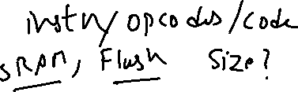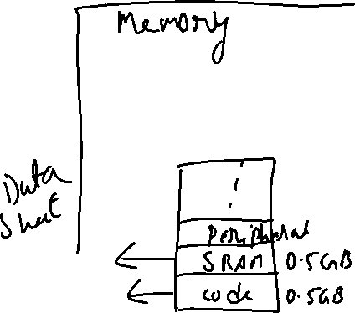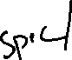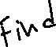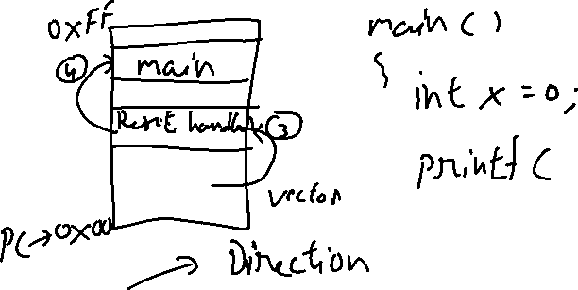



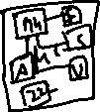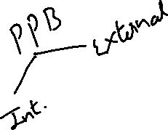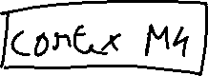









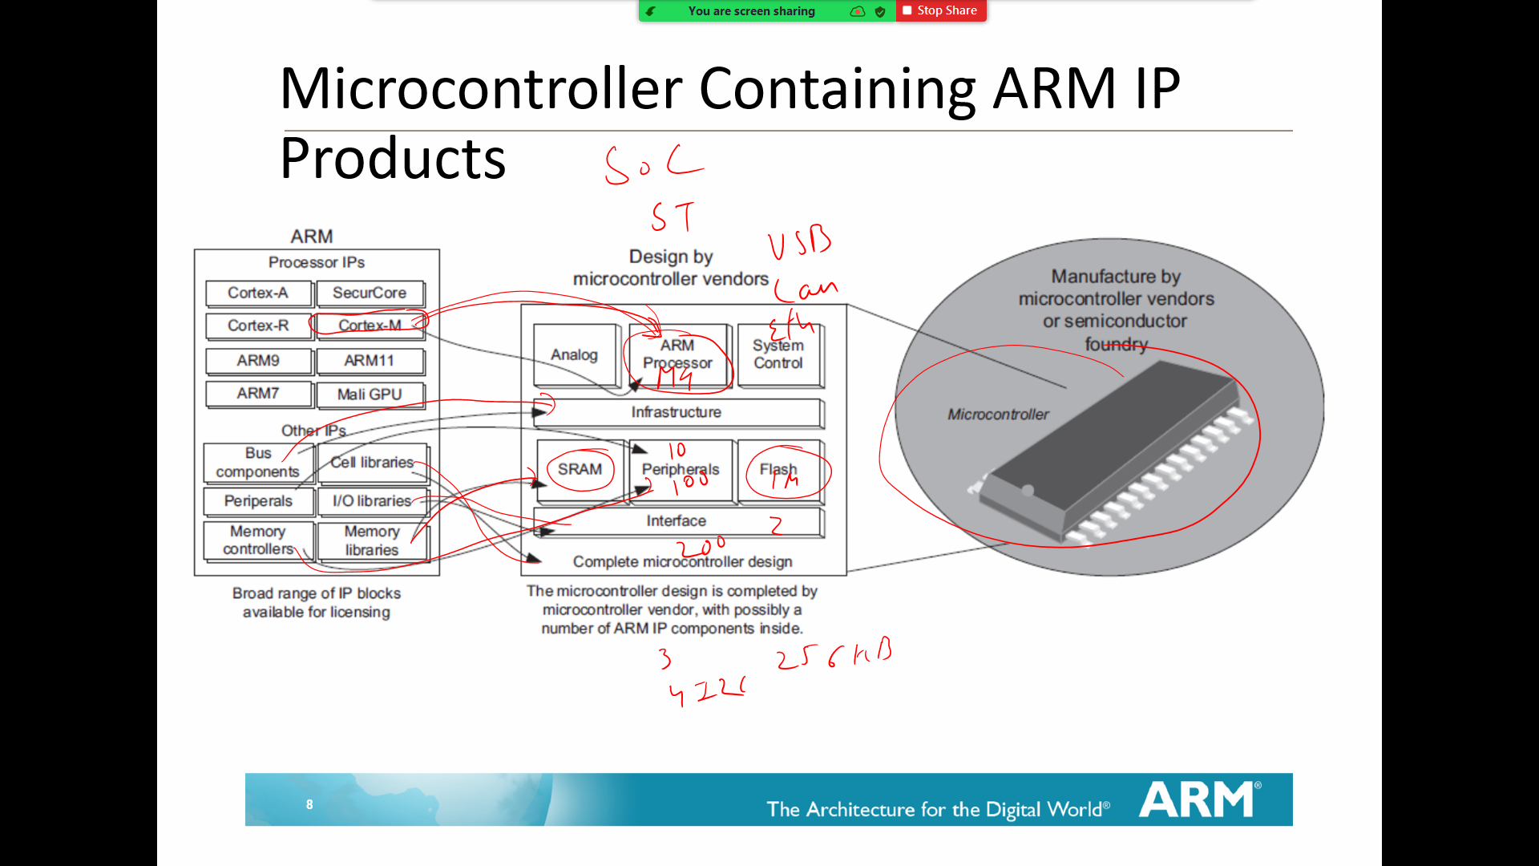

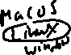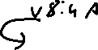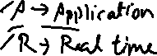





**Assembly Language**

MOV vs MOVS



Use of #



SYNTAX OF ASM Instruction



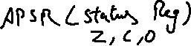



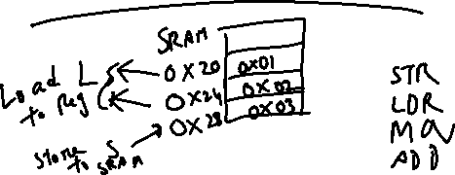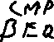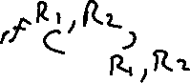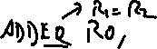

TEMP1 EQU 0x20

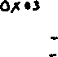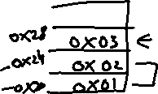

TEMP2 EQU 0x24



TEMP3 EQU 0x28

LDR R0, =TEMP1 ; Address 0x20 will be loaded in R0

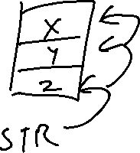

LDR R1, =TEMP2 ; Address 0x24 will be loaded in R1



LDR R4, =TEMP3 ; Address 0x28 will be loaded in R4

LDR R2, [R0] ; R2= 01

LDR R3, [R1] ; R3= 02

ADD R3,R2 ; R3=R3+R2

STR R3, [R4] ; Store the Value in 0x28 address











MOV R0, #0x20



MOV R1, #0x24



MOV R2, #0x28



LDR R3, [R0]

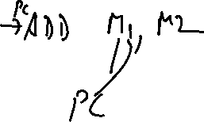

LDR R4, [R1]



ADD R3, R4

; Stores a 8-bit Value at location 0x28



STR      R3, [R2]

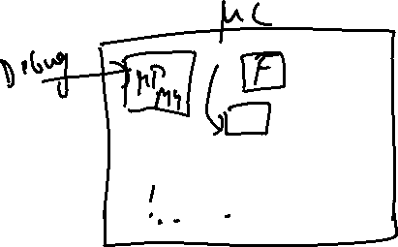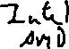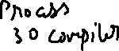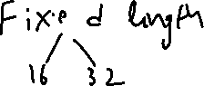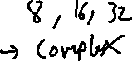

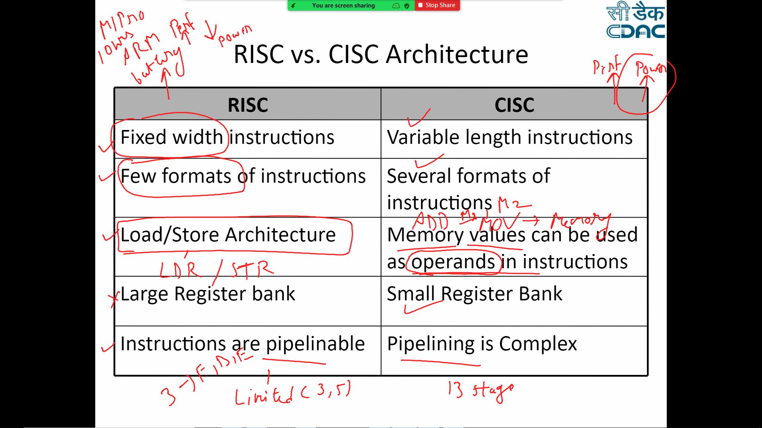

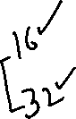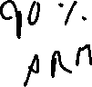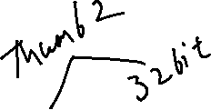

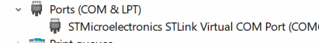Hardware





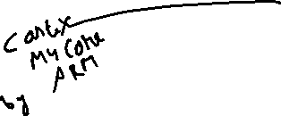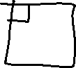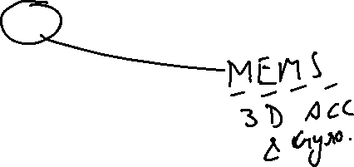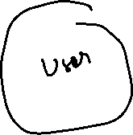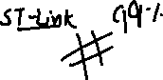

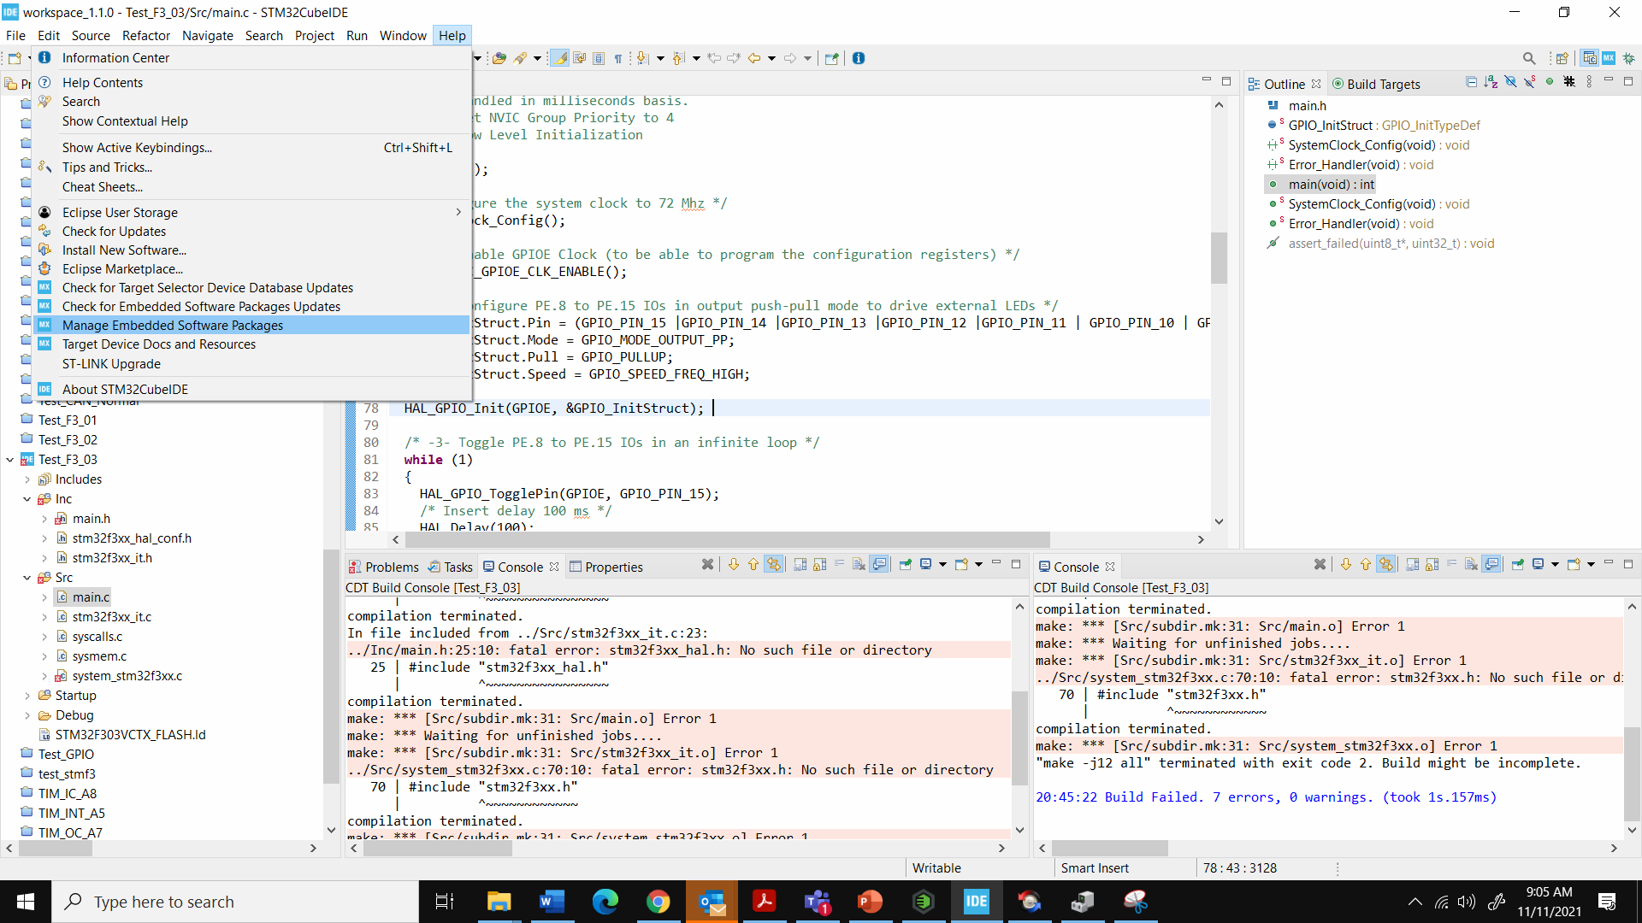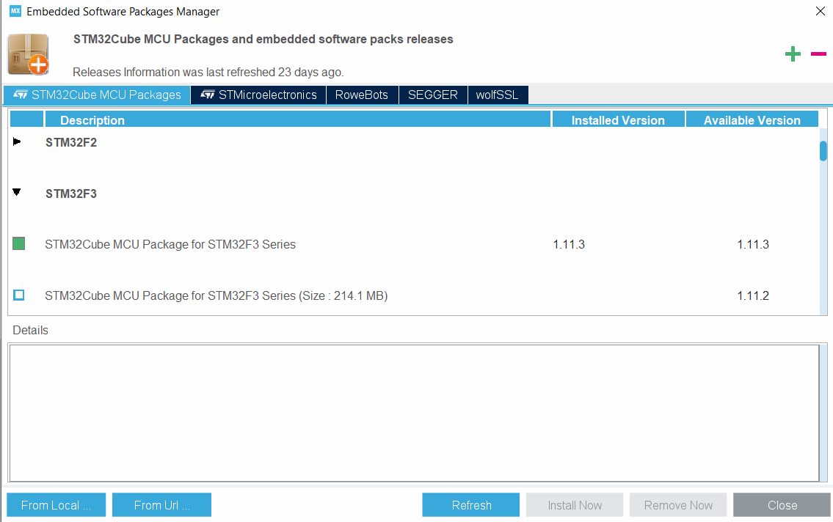

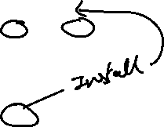

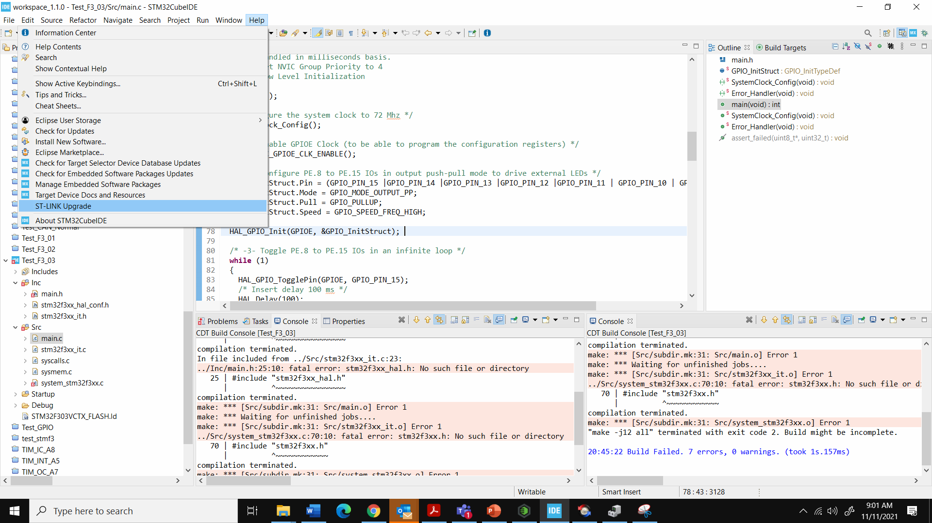

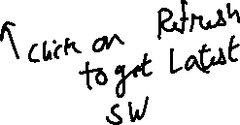

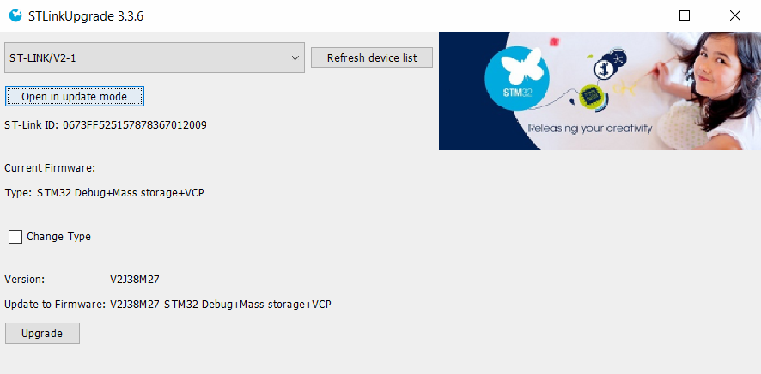



How to read Reference Manual (Data Sheet)

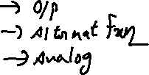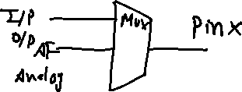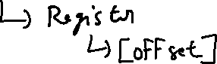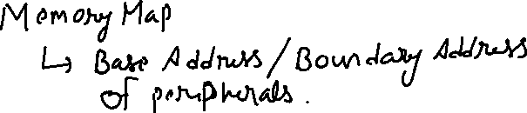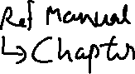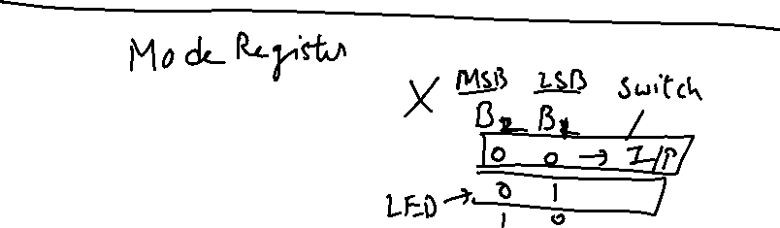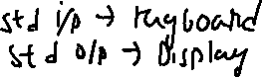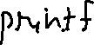

Laptop/ PC

USB

Debugger

STM32F303VC

Cortex M4

Core

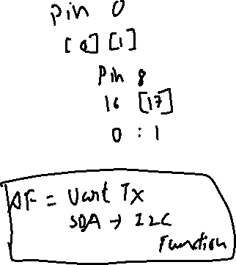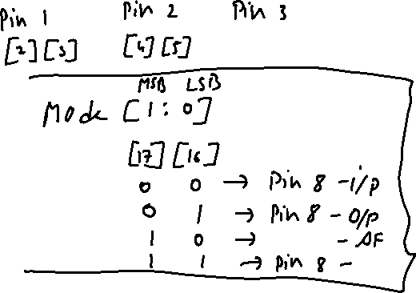

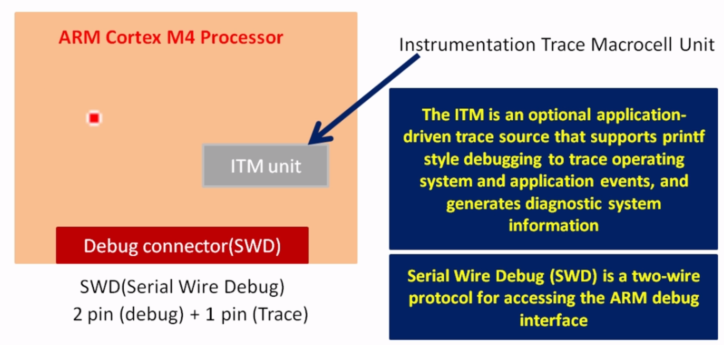

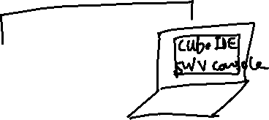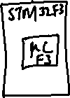

1. Write any prog that has printf.
2. In syscalls.c add Debugging code , modify _write API _IO_PUTCHAR >> ITM_SendChar
3. Debug your code , Enable SWV in the debugging option tab (Check SWV & update clock to 8.0)
4. Click on apply and Debug will take you to debugging session
5. Open Window option->Show View->SWV->SWV ITM Data Console
6. Update Settings of SWV ITM Data Console, Enable Port 0 (Check on port 0)
7. Start your Trace Recording by clicking Red button on SWV ITM Data Console
8. Resume/Run your Program in debugger.

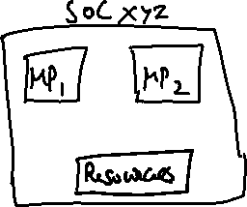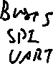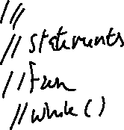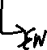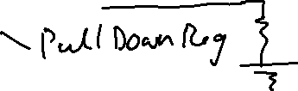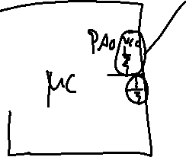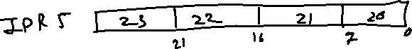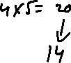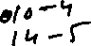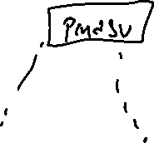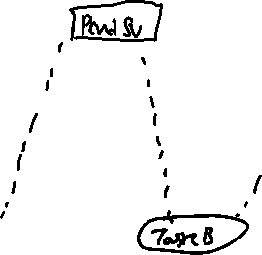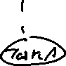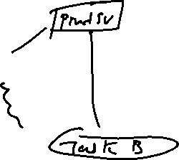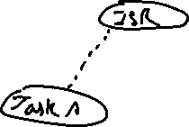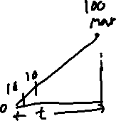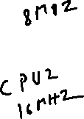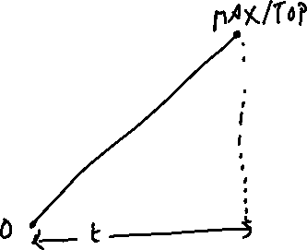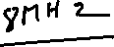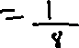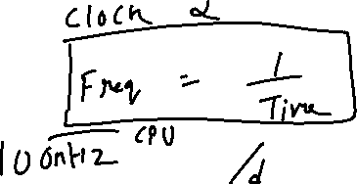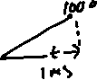

Part 1 For a Delay of 200 MS , if Prescalar is 8000 and APB Bus Freq is 8Mhz, What is the count Required?

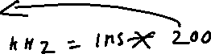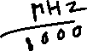

Part 2 For a Delay of 500 MS , if Prescalar is 8000 and APB Bus Freq is 8Mhz, What is the count Required?



Part 3 For a Delay of 50 MS , if Prescalar is 8000 and APB Bus Freq is 8Mhz, What is the count Required?



If Clock Freq for ABP1 Timer Bus is 32Mhz and we want a delay for 1MS (Tick) , what will be the Prescalar?



If Clock Freq for ABP1 Timer Bus is 32Mhz and Prescalar is 8000 , what will be the Delay or Tick?

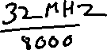

ADC

**TADC = TSMPL + TSAR = [ 1.5 |min + 12.5 |12bit ] x TADC_CLK**

